From
“A Summary of the Christian Faith”
by David Chytraeus (1568)

Why is the Son of God called the Logos or the Word?

First, with respect to the eternal Father, because He is the image of the Father in which shine fully the wisdom, goodness and essence of the Father, just as our speech is the reflection of the thoughts of our mind.

Second, with respect to ourselves because He was the first to speak to mankind the promise of the Gospel, brought forth from the secret bosom of the Father and then repeated it in conversation with the fathers, as we read in John 1: “The Son, who is in the bosom of the Father, He has made Him known.”

Third, because He is effective through the ministry of His Word or the Gospel, and He kindles a true knowledge of the eternal Father, true consolation and life by speaking or through His Word. “No one knows the Father except the Son and anyone to whom the Son chooses to reveal Him,” Matt. 11. “The word of God is living and active,” Heb. 4. “Thy word gave me life,” Ps. 119.
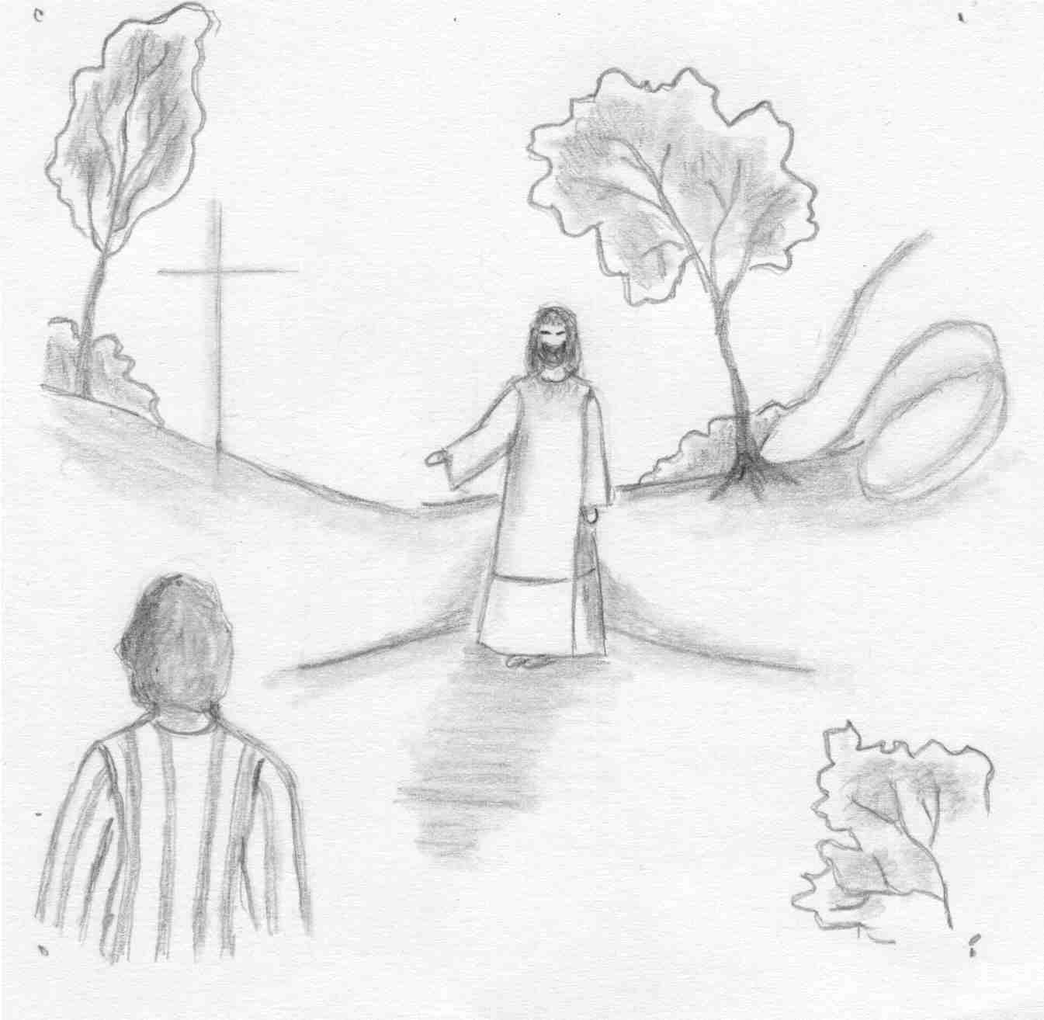
But who do you say that I am?
Change this frame and the box above by clicking the body of the text and adding the particulars.
The artwork is by Sharon Geiser. Permission to use this copyrighted graphic is limited to congregational use. The quotation above is by David Chytraeus and is from his 1568 work A Summary of the Christian Faith. The English translation is by Rev. Dr. Richard Dinda and is published by Repristination Press. For information on this book and other books by Repristination Press see the website below.

This bulletin cover provided by www.scholia.net and is made available without cost.

4 July Anno Domini 2004

Trinity 4 / Pentecost 5

To place the graphic on this page:
Copy the graphic on the previous page.
Click on the open space above and a graphic box should appear. Paste the graphic.

Change this frame and the box above by clicking the body of the text and adding the particulars. (See the previous page for an example.)
The artwork is by Sharon Geiser. Permission to use this copyrighted graphic is limited to congregational use. The quotation above is by David Chytraeus and is from his 1568 work A Summary of the Christian Faith. The English translation is by Rev. Dr. Richard Dinda and is published by Repristination Press. For information on this book and other books by Repristination Press see the website below.

This bulletin cover provided by www.scholia.net and is made available without cost.

4 July Anno Domini 2004
Trinity 4 / Pentecost 5
But who do you say that I am?

From
“A Summary of the Christian Faith”
by David Chytraeus (1568)

Why is the Son of God called the Logos or the Word?

First, with respect to the eternal Father, because He is the image of the Father in which shine fully the wisdom, goodness and essence of the Father, just as our speech is the reflection of the thoughts of our mind.

Second, with respect to ourselves because He was the first to speak to mankind the promise of the Gospel, brought forth from the secret bosom of the Father and then repeated it in conversation with the fathers, as we read in John 1: “The Son, who is in the bosom of the Father, He has made Him known.”

Third, because He is effective through the ministry of His Word or the Gospel, and He kindles a true knowledge of the eternal Father, true consolation and life by speaking or through His Word. “No one knows the Father except the Son and anyone to whom the Son chooses to reveal Him,” Matt. 11. “The word of God is living and active,” Heb. 4. “Thy word gave me life,” Ps. 119.

